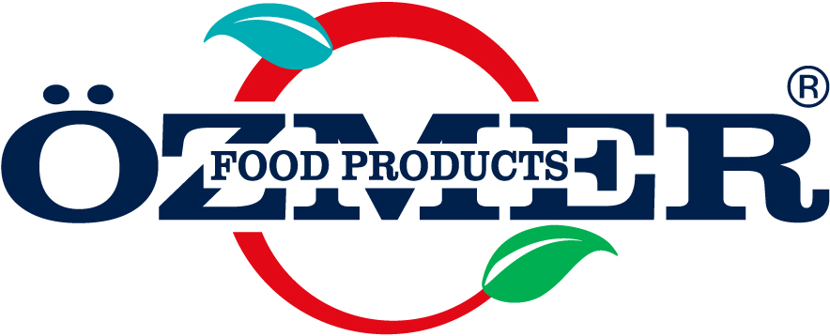 | PROFESSIONAL SAUCE  PRODUCT SPECIFICATION |  |  | Document No : SP-FP-328  1st Issue : 08.11.2017  Revision No : 03  Revision Date: 11.06.2025  Page No : 1 / 1
- GENERAL CHARACTERISTICS:
Trade Mark : FO FOOD PRODUCTS
Product Name : TIRAMISU FLAVORED SAUCE
Packaging Amount/Type : 2,5 kg PE Bottle
Shipment : Shipped in closed cartoon packaging on lorries with closed containers.
Intended Area Type of Usage : Generally used in human nutrition, may be used for zesting hot and cold drinks or coating ice cream, milky dessert,
cakes,tarts and inside the waffles. Also, maybe used in making fruited ice cream and frozen. As well as maybe
used to give color and flavor to pastry and cake dough, pies, cream, whipped cream, jellys and candy. As a sauce,
gives a delicious taste to the product applied. Saves time and labour since it is applied directly.
Type of Usage : Applied directly.
Storing Conditions : It should be stored in its original packaging, 20-22º C under dry conditions, and direct sunlight should be avoided.
Shelf life : The shelf life under defined storing conditions and in unopened packaging is 2 year.
2. PRODUCT INGREDIENTS :
INGREDIENTS | CLASS | EC CODE | MAXIMUM  DOSAGE | PERCENTAGE
Glucose Syrup | — | — | — | 47%
Water | — | — | — | 24,4%
Sugar | — | — | — | 13%
Modified corn starch | — | — | — | 4%
Glycerine | Humectant | E 422 | — | 4%
Skimmed Milk Powder (milk) | — | — | — | 4%
Whey Powder | — | — | — | 3%
Citric Acid, Tripotassium citrate | Acidity Regulator | E 332ii, E 330 | QS | 0,3 %
Plain caramel | Colorant | E 150 a | QS | 0,1%
Flavoring (tiramisu) | Flavoring | — | — | 0,1 %
Potassium Sorbate | Preservative | E 202 | 1g/kg | 0,1 %
3.NUTRITIONAL INFORMATION: (Energy and Nutrition Facts 100 g)*;
Energy | 1040 kj/248 kcal
Total Fat | 0,0 g
-Saturated | 0,0 g
Cholesterol | 0,0 g
Total Carbohydrate | 65,4 g
Sugar | 35,5 g
Starch | 16,2 g
Dietary Fibre | 0,0 g
Protein | 1,8 g
Sodium/salt | 0,12 g /0,3 g
*( According to European Regulation 90/496/CE and subsequent modifications)
4. PHYSICAL CHARACTERISTICS :
Color/Taste/Odor : It has authentic tiramisu color, taste and odor.
Appearance : It is of homogenous structure. Does not have physically distinct. It does not contain foreign materials.
5. CHEMICAL CHARACTERISTICS :
- pH : 5.5 ± 0.2 - Briks : 65 ± 2.0
6. : CONTAMINANTS:
Aflatoxin B1 (ppb) | Max.2
Aflatoxin B1+B2+G1+G2 (ppb) | Max. 4
Aflatoxin M1(ppb) | Max. 0,05
Okratoxin A (ppb) | Max. 5
Fumonisin (ppb) | Max.1000
Cadmium (Cd) (mg/kg) | Max. 1
Arsenic (As) (mg/kg) | Max.3
Mercury (Hg) (mg/kg) | Max. 1
Lead ( Pb) (mg/kg) | Max. 10
7. MICROBIOLOGICAL CHARACTERISTICS :
MICROORGANISM NAME | MICROBIOLOGICAL VALUE | ANALYSIS METHOD
Mould and Yeast (kob/g) | 1.0 × 10² | ISO 7954 – ISO 21527 -1 /2
Salmonella | 0/25 g-ml | EN/ISO 6579
8.ALLERGEN ALERT:
Contains milk and milk products. (According to European Regulation 2000/13/EC and subsequent modifications)
9.GMO DECLARATION:
OZMER PASTACILIK A.S. declares under its responsibility that the product of this chart is produced with no GMO.
( According to European Regulation 2003/1829/CE,2003/1830/CE and subsequent modification.
10.REFERENCES:
OZMER PASTACILIK A.S. declares under its responsibility that the product of this chart is in accordance with the law in force;
* European Regulation 1333/2008/EC * European Regulation 1881/2006/EC
* European Regulation 2073/2005/EC * European Regulation 396/2005/EC and subsequent modifications.
PREPARED BY: |  | REVIEWED BY: | APPROVED BY:
R&D Manager |  | Quality Management Manager | General Manager

